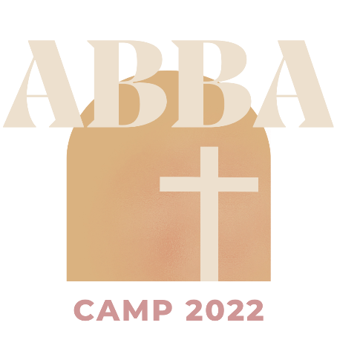**All Nations Baptist Church**

**2024 ABBA Camp**

**July 30-August 2nd, 2024**

**“Gaze Fixed Upward”**

**Registration Form**

Each Student must have a registration form completed in order to attend

Youth Name (First) _____________________________ (Last) ________________________________

Youth Birth Date _______________ Age _________________ Grade _____________________

Gender ________________

Name of Parent(s) or Legal Guardian: ______________________________________________________

Street Address: _______________________________________________________________________

City _________________________________________ Zip Code _________________________

Home Phone ______________________________ Cell Phone ______________________________

E-mail (print) __________________________________________________________________________

T-Shirt Size:__________________________________________

**Emergency Contact:**

Name__________________________________ Relationship_______________________________

Phone Number for Emergency Contact: ____________________________________________________

Please list allergies, chronic illness, or health conditions: __________________________________________________________________________________________________________________________________________________________________________

I permit my child’s name and food allergies to be posted for ABBA staff members to see

_____ Yes _____ No

Pictures of my child may be used in future ABBA promotional material. _____ Yes _____No

**Permission to Participate; Release, Waiver of Liability, and Indemnity Agreement**

I/we give permission for _____________________________ (name of child/youth to participate in the activities of All Nations Baptist Church, both on the church premises and elsewhere. In consideration of the opportunity of my/our child/youth to participate in the activities of All Nation Baptist Church, I/we release All Nations Baptist Church, its officers, agents, employees, staff, and volunteers from any and all liability of any kind whatsoever for any loss or injury to my/our child/youth arising from my/our child/youth’s participation in the activities of All Nations Baptist Church; and I/we agree to indemnify and hold forever harmless the All Nations Baptist Church, its officers, agents, employees, staff, and volunteers from any and all liability of any kind whatsoever for loss or injury to my/our child/youth arising from activities on or off the premises of All Nations Baptist Church or resulting from traveling to or from the activities of All Nations Baptist Church.

I/we understand and agree that this permission and agreement shall remain in effect until revoked in writing by me/us, and I/we understand and agree that it is my/our responsibility to update our child/youth’s medical and insurance information as changes occur.

**Parent/Guardian Signature: ______________________________________ Date: _______________**

**Permission to Travel in Church Vehicle or Leader’s Vehicle**

I/we hereby give my permission for the individual listed above to ride the All Nation Baptist Church van, or a leader’s vehicle to attend ABBA Camp and shuttle to and from all of its activities. I understand that my youth will be under adult supervision. I further understand that in signing this permission slip, I release and hold harmless All Nations Baptist Church. By signing this permission slip, I release and hold harmless its trustees, officers, employees and any volunteers from any liability, past or future, fully and completely. I authorize the staff or designated medical professionals and/or volunteers to administer emergency medical assistance if I cannot be reached.

**Parent/Guardian Signature: ______________________________________ Date: _______________**

**2024 ABBA Registration Fee Information**

Registration is required for 2024 ABBA camp. The Registration fee is **$60 per child** (Or **$100 for 2 campers under the same household).**

**Campers who register before July 12th will be entered into a raffle for a free shirt!**

(If paying by check, please make all checks out to: ANBC with ABBA Camp in the memo line.)

Registration form can also be mailed to:

All Nations Baptist Church

1715 Mormon Trek Blvd

Iowa City, Iowa 52246