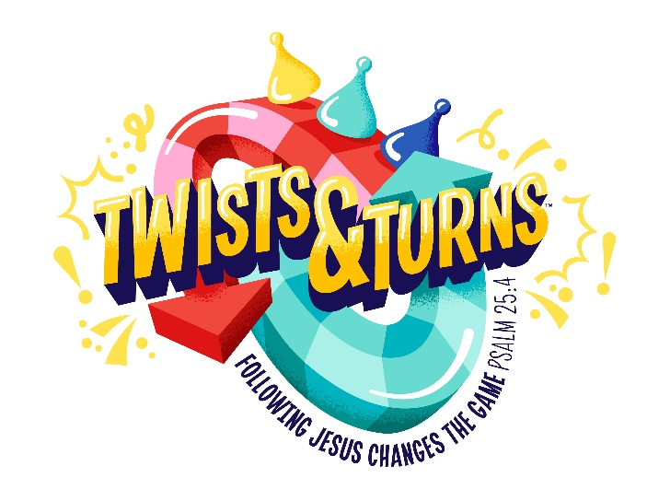
All Nations Baptist Church
2023 Vacation Bible School (VBS)
June 12-16th
6-8:30 pm
Registration Form
Each Student must have a registration form completed in order to attend
Child’s Name (First) _____________________________ (Last) ________________________________
Child’s Birth Date _______________ Age _________________ Grade _____________________
Name of Parent(s) or Legal Guardian: ______________________________________________________
Street Address: _______________________________________________________________________
City _________________________________________ Zip Code _________________________
Home Phone ______________________________ Cell Phone ______________________________
E-mail (print) __________________________________________________________________________

Emergency Contact:
Name__________________________________ Relationship_______________________________
Phone Number for Emergency Contact: ____________________________________________________
Please list allergies or health conditions: __________________________________________________________________________________________________________________________________________________________________________
I permit my child’s name and food allergies to be posted for VBS staff members to see
_____ Yes _____ No
Pictures of my child may be used in future VBS promotional material. _____ Yes _____No
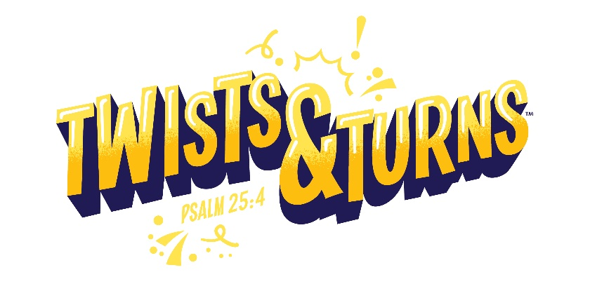
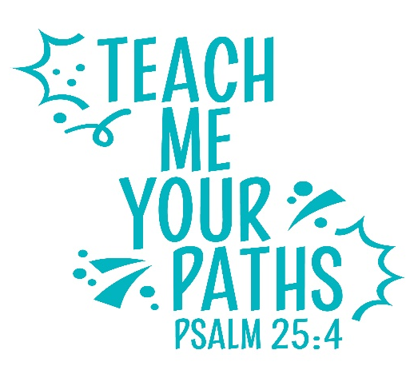
Permission to Travel in Church Vehicle or Leader’s Vehicle
I/we hereby give my permission for the individual listed above to ride the All Nation Baptist Church van, or a leader’s vehicle to attend VBS. I understand that my children will be under adult supervision. I further understand that in signing this permission slip, I release and hold harmless All Nations Baptist Church. By signing this permission slip, I release and hold harmless its trustees, officers, employees and any volunteers from any liability, past or future, fully and completely. I authorize the staff or designated medical professionals and/or volunteers to administer emergency medical assistance if I cannot be reached.
Parent/Guardian Signature: ______________________________________ Date: _______________

2023 VBS Registration Fee Information
The Registration fee is $10 per child and includes a t-shirt and a music cd. (Max of $20 per families)
The Registration fee is not required to attend VBS. Please note that children without a registration fee will not receive the t-shirt and cd.
(If paying by check, please make all checks out to: ANBC with VBS in the memo line.)
Registration form can also be mailed to:
All Nations Baptist Church
1715 Mormon Trek Blvd
Iowa City, Iowa 52246

Child’s Name (First) _____________________________ (Last) ________________________________

T-Shirt Size:
_____ Youth X-small _____ Youth Small _____ Youth Medium _____ Youth Large
_____ Other (see Pastor Tim)

